Practical No. 15
Aim : ALP to count number of Positive and Negative numbers in given array
Name : Danish Altaf Solkar Class : CO - B
Enrolment no. : 24111590805 Batch : 2
Code :-
assume cs:code
assume ds:data
data segment
arr DB 12H,09H,-08H,05H,-01H
pos DB ?
neg DB ?
data ends
code segment
start:
MOV AX,data
MOV DS,AX
MOV AX,0000H
LEA SI,arr
MOV CL,05H
UP:
MOV AL,[SI]
CMP AL,00H
JS DOWN
INC SI
INC DL
LOOP UP
JMP EXIT
DOWN:
INC SI
INC DH
LOOP UP
EXIT:
MOV neg,DH
MOV pos,DL
INT 03H
code ends
end start

OUTPUT :-
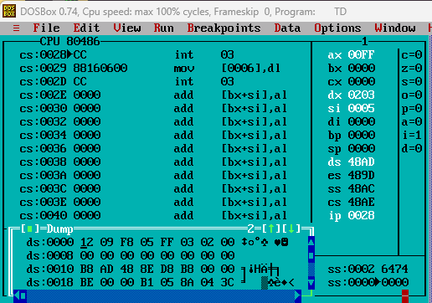

Process related  (15) | Product related  (10) | Total Marks  (25) | Signature

